*Student: Melis Kilic*

**Morphological operations for binary images - report**

**MB-1. Erosion, dilation, opening and closing**

**Task 1a Erosion and multiple erosion**

%% Task 1a

clearvars;

close all;

clc;

originalImage = imread('ertka.bmp');

se = strel('square', 3);

singleErosion = imerode(originalImage, se);

doubleErosion = imerode(singleErosion, se);

tripleErosion = imerode(doubleErosion, se);

% Display

figure;

subplot(2,2,1);

imshow(originalImage);

title('Original Image');

subplot(2,2,2);

imshow(singleErosion);

title('Single Erosion');

subplot(2,2,3);

imshow(doubleErosion);

title('Double Erosion');

subplot(2,2,4);

imshow(tripleErosion);

title('Triple Erosion');

**Result of the code:**

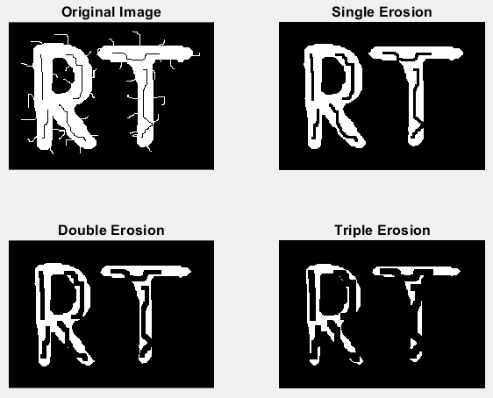

**Task 1b Erosion with a dedicated structuring element**

%% Task 1b

clearvars;

close all;

clc;

image = imread('face.bmp');

se_diagonal = [0 0 1;

0 1 0;

1 0 0];

se_vertical = [0 1 0;

0 1 0;

0 1 0];

% Erosion

removedLines1 = imerode(image, se_diagonal);

removedLines2 = imerode(image, se_vertical);

% Display

figure;

subplot(1,3,1);

imshow(image);

title('Original Image');

subplot(1,3,2);

imshow(removedLines1);

title('Removing lines /');

subplot(1,3,3);

imshow(removedLines2);

title('Removing lines \');

**Result of the code:**

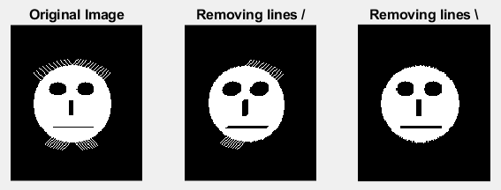

**Task 1c Comparison of erosion, dilation, opening and closing**

%% Task 1c

clearvars;

close all;

clc;

image = imread('ertka.bmp');

se = strel('square', 5);

erosion = imerode(image, se);

dilation = imdilate(image, se);

opening = imopen(image, se);

closing = imclose(image, se);

opening_then_closing = imclose(imopen(image, se), se);

% Display

figure;

subplot(2,3,1);

imshow(image);

title('Original Image');

subplot(2,3,2);

imshow(erosion);

title('After Erosion');

subplot(2,3,3);

imshow(dilation);

title('After Dilation');

subplot(2,3,4);

imshow(opening);

title('After Opening');

subplot(2,3,5);

imshow(closing);

title('After Closing');

subplot(2,3,6);

imshow(opening_then_closing);

title('After Opening, then Closing');

**Result of the code:**

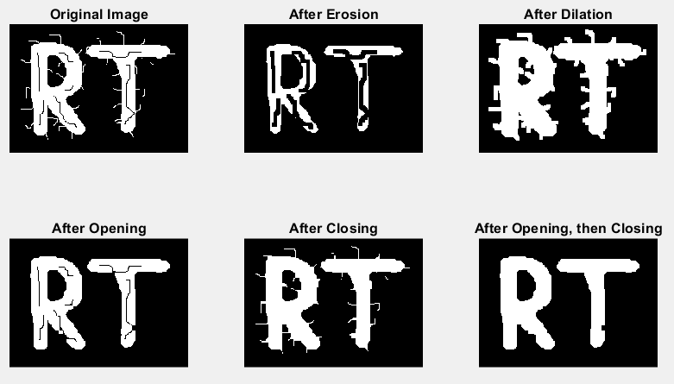

**MB-2. Hit or miss transform**

clearvars;

close all;

clc;

image = imread('hom.bmp');

SE1 = [0 1 0;

1 1 1;

0 1 0];

SE2 = ~SE1;

resultImage = bwhitmiss(image, SE1, SE2);

% Display

figure;

subplot(1,2,1);

imshow(image);

title('Original Image');

subplot(1,2,2);

imshow(resultImage);

title('After Hit or Miss Transform');

**Result of the code:**

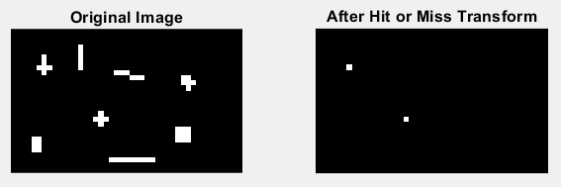

**MB-3. Morphological reconstruction**

clearvars;

close all;

clc;

image = imread('text.bmp');

vertical_mask = ones(51, 1);

opened_image = imopen(image, vertical_mask);

figure;

subplot(2, 1, 1);

imshow(image);

title('Original Image');

subplot(2, 1, 2);

imshow(opened_image);

title('Opening (only vertical parts of letters)');

%-----------------------------

eroded_image = imerode(image, vertical_mask);

reconstructed_image = imreconstruct(eroded_image, image);

figure;

subplot(3, 1, 1);

imshow(image);

title('Original image (also used as the mask image)');

subplot(3, 1, 2);

imshow(eroded_image);

title('Eroded image (used as the marker image) ');

subplot(3, 1, 3);

imshow(reconstructed_image);

title('Reconstruction (letters with vertical part) ');

**Result of the code:**

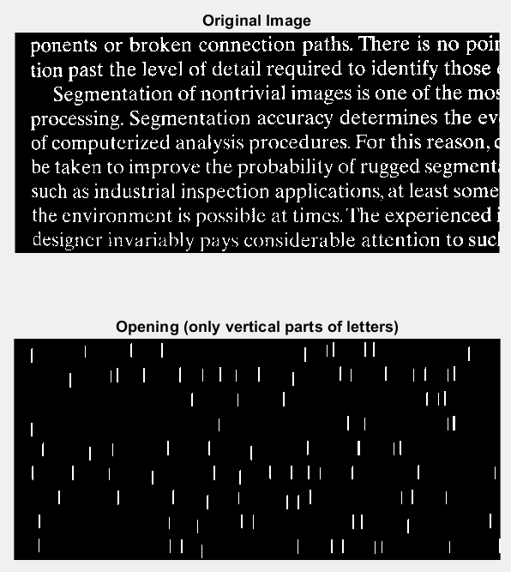 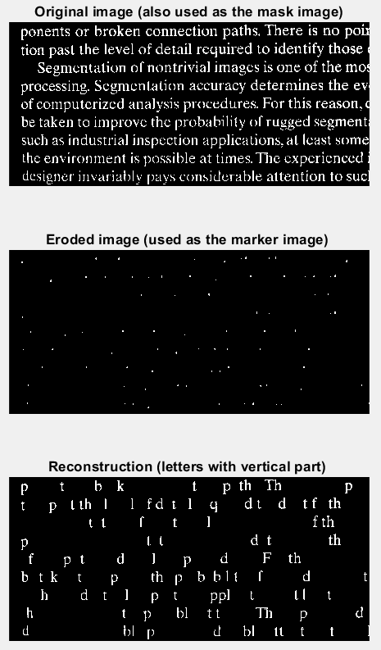

**MB-4. Other morphological operations: thinning, skeletonization, filling holes, clearing borders**

**Task 4a Thinning**

%% Task 4a

clearvars;

close all;

clc;

image = imread('fingerprint.bmp');

thinned_image_1 = bwmorph(image, 'thin', 1);

thinned_image_2 = bwmorph(image, 'thin', 2);

thinned_image_inf = bwmorph(image, 'thin', Inf);

figure;

subplot(2, 2, 1);

imshow(image);

title('Original Image');

subplot(2, 2, 2);

imshow(thinned_image_1);

title('Thinning');

subplot(2, 2, 3);

imshow(thinned_image_2);

title('2x Thinning');

subplot(2, 2, 4);

imshow(thinned_image_inf);

title('\infty Thinning');

**Result of the code:**

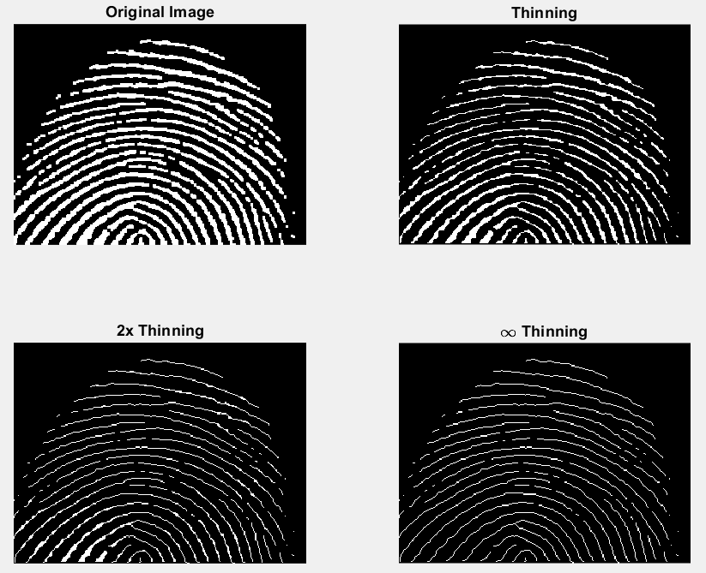

**Task 4b Skeletonization**

%% Task 4b

clearvars;

close all;

clc;

image = imread('bone.bmp');

skeleton_image = bwmorph(image, 'skel', Inf);

figure;

subplot(1, 2, 1);

imshow(image);

title('Original Image');

subplot(1, 2, 2);

imshow(skeleton_image);

title('Skeleton');

**Result of the code:**

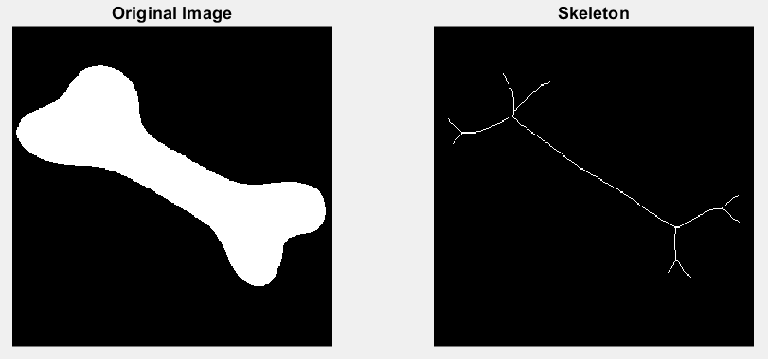

**Task 4c Filling holes**

%% Task 4c

clearvars;

close all;

clc;

image = imread('text.bmp');

filled_image = imfill(image, 'holes');

figure;

subplot(1, 2, 1);

imshow(image);

title('Original Image');

subplot(1, 2, 2);

imshow(filled_image);

title('Image with Holes Filled');

**Result of the code:**

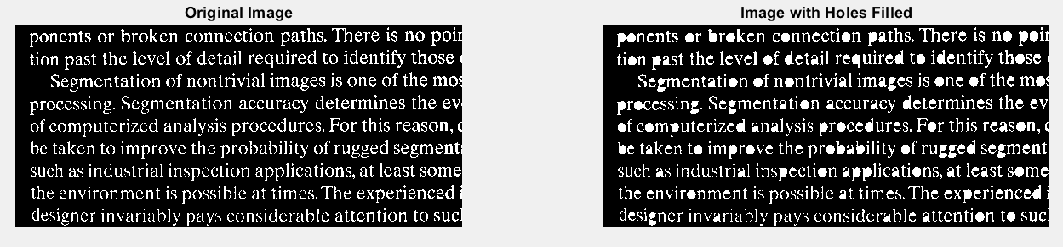

**Task 4d Clearing the boarder**

%% Task 4c

clearvars;

close all;

clc;

image = imread('text.bmp');

cleared_image = imclearborder(image);

figure;

subplot(1, 2, 1);

imshow(image);

title('Original Image');

subplot(1, 2, 2);

imshow(cleared_image);

title('Image with Cleared Border');

**Result of the code:**

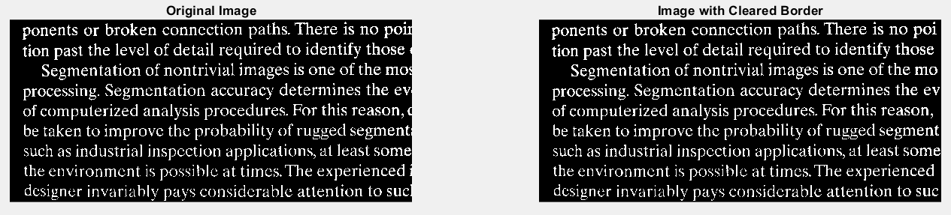

**MB-5. Morphological operations on an artificial image**

clearvars;

close all;

clc;

% Image

A = zeros(11);

A(3:7, 3:9) = 1;

A(3, 6) = 0;

A(4, 6) = 0;

A(8, 6) = 1;

A(9, 6) = 1;

% Visualize the image using command imagesc(A).

figure;

subplot(2, 3, 1);

imagesc(A);

colormap('gray');

title('Original Image');

se = ones(3);

eroded_image = imerode(A, se);

subplot(2, 3, 2);

imagesc(eroded_image);

colormap('gray');

title('Eroded Image');

opened_image = imopen(A, se);

subplot(2, 3, 3);

imagesc(opened_image);

colormap('gray');

title('Erosion -> Dilation (Opening)');

dilated_image = imdilate(A, se);

subplot(2, 3, 5);

imagesc(dilated_image);

colormap('gray');

title('Dilated Image');

closed_image = imclose(A, se);

subplot(2, 3, 6);

imagesc(closed_image);

colormap('gray');

title('Dilation -> Erosion (Closing)');

**Result of the code:**

